2024
Award Application

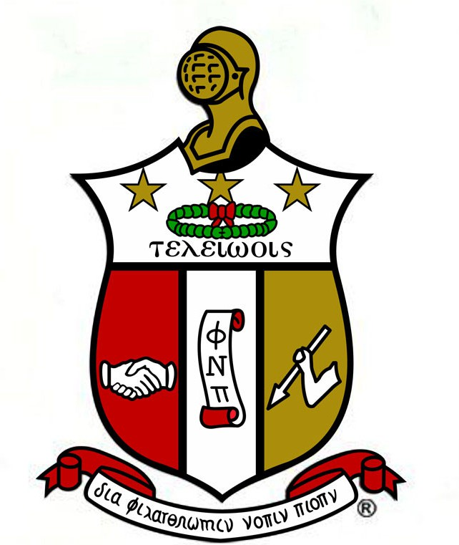

Men of Kappa Achievement Award

For additional information, contact Eric K. Nelums at Ericnelums@gmail.com
Or Deriane Cox at cderiane@gmail.com

Application Check List
Before sealing your package, please make sure all items listed below are included:

- Completed and signed scholarship application (Signed by applicant and parent/guardian)
- Essay Topic: What does achievement mean to you and how has it shaped who you are today? MLA Format typed, double spaced no less than one page and no more than 2 pages.
- Two typed letters of recommendation (sealed)
- Proof of 40 hour s of community service
- Proof of active participation in church ministry
- Most Current High School Transcript or Grades
(Official school transcript required)
Missing any of the above items will result in an incomplete package and will not be considered for an award.

***Applications must be sent electronically to Ericnelums@gmail.com and cderiane@gmail.com no later than May 3, 2024***

Dear Scholarship Applicant,

Thank you for your interest in the Men of Kappa Achievement Award. This esteemed scholarship is administered by the Men of Kappa Alpha Psi Fraternity, Inc. at Turner Chapel A.M.E Church. We firmly believe in the potential of every individual to achieve greatness. Our mission is to provide deserving high school graduating male seniors at Turner Chapel A.M.E. Church with financial assistance to alleviate the burden of post-secondary educational expenses.

Each completed application received by the deadline will be meticulously and impartially evaluated. Rest assured that all information provided will be treated with the utmost confidentiality by the Men of Kappa Scholarship Committee. Please note that all applications become the property of the committee and will not be returned.

The recipient(s) of the award will be notified by May 15, 2024, and their achievement will be publicly celebrated during Turner Chapel AME’s Graduate Celebration.

Before submitting your application, we urge you to carefully review it to ensure its completeness. The Men of Kappa Scholarship Committee reserves the right to process only those applications that are deemed complete and have been submitted by the application deadline.

Respectfully,

Men of Kappa Scholarship Committee

THE APPLICANT IS RESPONSIBLE FOR SUBMITTING ALL REQUIRED INFORMATION IN ONE COMPLETE ELECTRONIC PACKAGE.

Guidelines

Award is open to males who are planning to attend an accredited post- secondary institution as a full-time student and meet all of the below criteria:
- Active member of Turner Chapel AME Church
- Minimum Cumulative GPA of 2.0 on a 4.0 scale
- Official proof of acceptance from a two year or four-year accredited post- secondary institution
- Proof of completion of 40 hours of community service on the agency/organization’s letterhead
- Submit two letters of references from a high school teacher/counselor, administrator, or community or church leader. At least one of the two letters of reference should come from the community service organization. Letters from relatives are not acceptable.
- Participate in an interview (if requested)

ApplicationProcess

Applicants must submit by published deadline items found on the packet checklist. Packets must be submitted electronically and will not be accepted personally by members of the fraternity.

** Submit Application To: Men of Kappa Scholarship Committee, email Ericnelums@gmail.com and cderiane@gmail.com mail by May 3, 2024

Selection Process and Notification
Scholarship recipients are selected according to merit on a competitive basis. In addition, applicants must demonstrate career and academic potential measured by a combination of factors, including past performance and career objectives. Not all applicants will receive awards. Applicants will be notified regarding the status of the award.

Award and Payment
The Men of Kappa Achievement Award is a one-time non- renewable award amount of paid directly to student(s) to assist in their pursuit of a post- secondary education. Amount awarded is based upon donations received from members of Kappa Alpha Psi.

Men of Kappa Achievement Award

SECTION 1 – APPLICANT INFORMATION
Name (Last, First, Middle)
Permanent Address
City | State/Province |  | Zip/Postal Code
Phone (Home) | Phone (Cell) |  | Email Address
Date of Birth |  | Birth State
Resident Status: [ ] US Citizen [ ] Permanent Residence |  | Parent(s) Name:
SECTION 2 – HIGH SCHOOL INFORMATION
School Name |  | GPA (Cumulative)
Address
City | State/Province |  | Zip/Postal Code
Phone Number |  | Graduation Date
SECTION 3 – COLLEGE INFORMATION
What school will you attend this fall? |  | Major
Future Professional Goals
SECTION 4 – COMMUNITY/EXTRACURRICULAR ACTIVITIES INFORMATION
Briefly describe any volunteer work you have done. Explain your role including dates and locations. Include documentation indicating your hours of community service.
SECTION 5 – HONORS/AWARDS INFORMATION
List honors and awards you have received. Please include list of scholarships you have received to date.
I certify that the information provided in the application is complete and accurate to the best of my knowledge. If requested, I agree to give proof of information I have provided in the application. I understand that falsification of information my result in the termination of any granted financial support and this
application becomes the property of the Men of Kappa Scholarship Committee.
Applicant’s Signature |  | Parent(s) Signature
Date |  | Date

